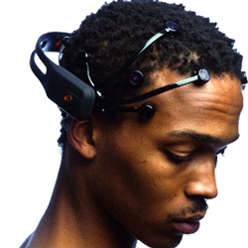 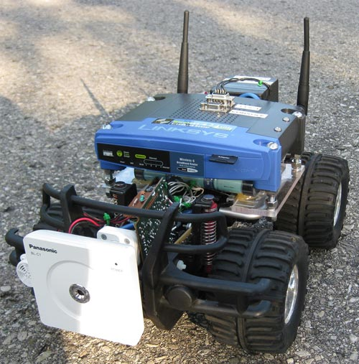

##### Jordan University of Science and Technology

The Department of Computer Science

Graduation project 1

“Unmanned Ground Vehicle controlled by brain “

**Group members :**

**Mohammad mwaffaq masadeh**

20102173033

**Rashed Khaled Abu Al-Asal**

20100173033

**Al_hassan Ali Abed Al_rahman**

20100173029

**Supervisor :**

**Dr. Mahmoud Al-Ayyoub**

**ABSTRACT**

Nowadays, security and safety are top priorities for most people. For tasks requiring inspection or monitoring of areas that are not “human-friendly,” robots present an appealing solution. Due to the nature of such tasks, fully autonomous systems might not be suitable. Instead, researchers propose to build systems where semi-autonomous vehicles equipped with cameras as well as other sensors are controlled by humans residing in safe locations.

In this project, we propose to build a system that uses unmanned ground vehicles (UGV) to perform the monitoring tasks. The control and coordination between these components will be handled by humans thousands of miles away using smart phone applications in part 1 and using headset brain Sensors in part 2. The system we are proposing will be capable of monitoring large hazardous regions with minimal risk, cost and human effort.

**Part 1:**

The general goal of this part is to provide a cost-efficient way to monitor large rural or hostile areas with minimal human effort and low risk. By allowing humans to use smart phones to control the UGVs, the monitoring process will have minimal risk on human life. Moreover, the operation cost associated with training humans to control the devices and paying their salaries will be drastically decreased. Finally, the use of smart phone applications means that there will no longer be a need for a centralized specially-equipped control station.

**Tools : remote control car (RC car) , Arduino Board , android app , windows phone app , some Sensors.**

**Part 2:**

The general goal of this part is to using our minds to control any thing hardware or software .The headset brain Sensors is provide us this capability , in this part we will use this headset to control the car in part 1

**Tools :** **Emotiv EPOC headset , SDK of EPOC**

Based on the latest developments in neuro-technology, Emotiv has developed a revolutionary new personal interface for human computer interaction.  The Emotiv EPOC is a high resolution, neuro-signal acquisition and processing wireless neuroheadset.  It uses a set of sensors to tune into electric signals produced by the brain to detect player thoughts, feelings and expressions and connects wirelessly to most PCs.